1. Hyper Text Markup Language
2. Markup Language is computer language that issued to apply layout and formating convetion to text document.It makes text more interactive and dynamic. It can turn text into images, tables, links, etc.

3)

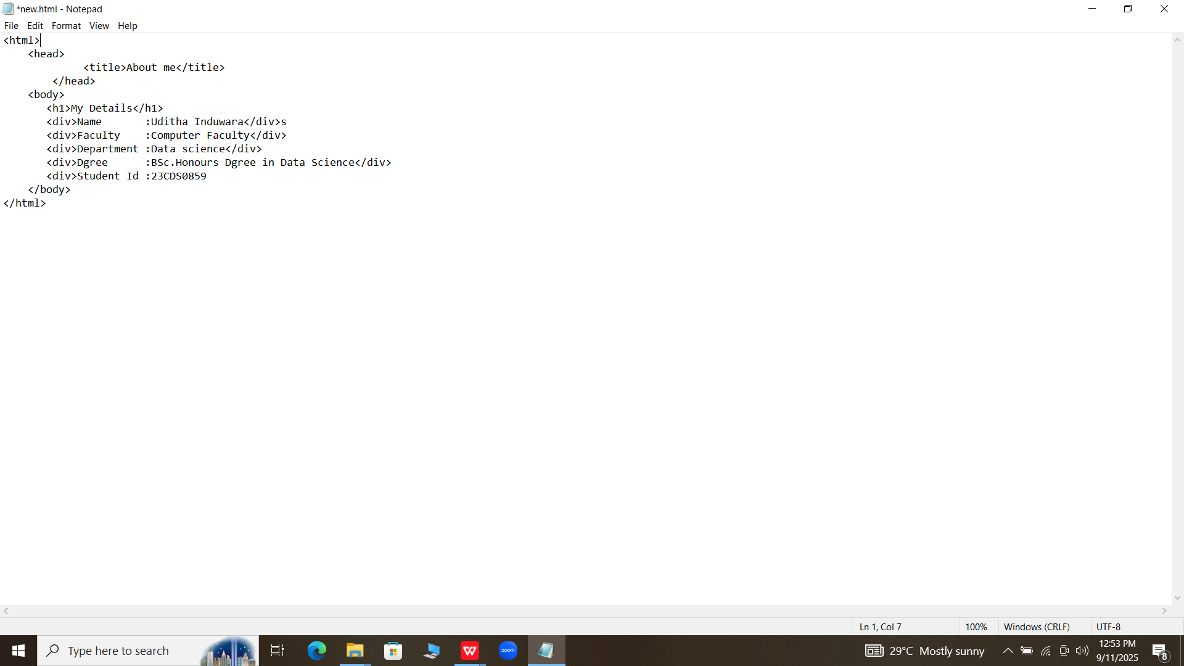

4)<html>

<head>

<title>DS1108 Practical</title>

</head>

<body>

<center>

<h1>Department of Data Science (DDS)</h1>

<h2>Faculty of Computing</h2>

<h3>Sabaragamuwa University of Sri Lanka</h3>

</center>

<p>The Department of Data Science(DDS) at the Faculty od computing, Sabaragamuwa University of Sri Lanka was established in 2022 offering <b>Bachelor of Science Honours in Data Science</b> with the aim of producing competent

Data Science graduates who are well equipped with theoretical and technical knowledge and skills to meet the increasing industry demand forData Science professionals.</p>

<p>At present,the Department is impowered with a highly qualified and competent panel of academic staff members who have graduated from well-known national and international universities and are specialized in core areas of Data

Science.</p>

<p>A comprehensive undergraduates curriculum is offered by the dgree programme, leading students to be industry leaders specialized in Data Science, with both general analytical skills and knowledge that reflect the specific nature of each

of the desciplines. The programme also paves the way for subsequent postgraduate-level knowledge transfer activities. Furthermore, the dgree programme significantly contributes to the body of knowledge in Data Science by

establishing and promoting a strong reserch culture among undergraduates, necessary to meet real-life challenges and to play a vital role in building th national economy.</p>

<p>The curriculum also presents a list of principles that embranced both general Data Science foundations as well as those that reflect the unique nature of the descipline.<p/>

The DDS is planning to improve the recognition and visibility of the University and to support the develpment of department through enhanced engagement and collaboration with both local and international data-analytical public

and private sector organization. These activities include:</p>

<u1>

<li>Designing and development of academic programmes</li>

<li>Designing and development of curricula</li>

<li>Reserch collaborations</li>

<li>Providing internships and employment</li>

<li>Commercialization of product</li>

<li>Conducting visiting lectures</li>

<li>Workshop, seminars, training, and mentoring programmes</li>

</u1>

<p>Such initiatives will be benificial for both the Department and the <b>ICT/BPM</b> industry of Sri Lanka, fostering innovation and building strong industry-academic partnerships.</p>

</body>

</html>